Practicum on the topic:

**“Human Brain Activity Classification”**



Under the Guidance of

Dr. Monika Bansal

Supervisor Signature:

Submitted By:

Utsav Singhal, 02917711622, AIML-A

Saarthak Bansal, 03917711622, AIML-A

Chakshu Gupta, 05817711622, AIML-A

Dhairya Goel, 06117711622, AIML-A

**Index**

|  |  |  |
| --- | --- | --- |
| **S.No.** | **Description** | **Page No.** |
| 1 | Introduction | 3 |
| 2 | Problem Statement | 3-4 |
| 3 | Background Study | 4 |
| 4 | Design Phase | 5 |
| 5 | Work Done | 6-8 |
| 6 | References | 9 |

1. **Introduction**

When it comes to caring for patients with neurological conditions, every moment counts. Imagine being in a hospital, where quick and accurate decisions can mean the difference between preventing harm and providing the best possible care. This is where electroencephalography (EEG) steps in as a crucial tool.EEG isn't just another medical instrument—it's like having a window into the intricate workings of the human brain, allowing doctors to monitor real-time brain activity with remarkable precision. Think of it as a guardian angel, quietly watching over patients in critical care settings, such as hospitals.With EEG recordings, healthcare professionals can uncover vital insights into neurological diseases like seizures or unusual brain activity. It's like having a detective on the case, revealing clues that help diagnose conditions and guide treatment plans tailored to each patient's needs.

In essence, EEG isn't just about data—it's about empowering caregivers to make informed decisions swiftly and confidently, ensuring that patients receive the timely attention and support they deserve. So, let's delve deeper into the world of EEG and explore how it's transforming patient care, one brainwave at a time. Epilepsy is a neurological disease characterized by rapid electrophysiological changes in the brain. More than 60 million people worldwide suffer from various types of epilepsy, especially in developing countries . Epilepsy detection is an important task in clinical research, which has stimulated extensive research into the design and diagnosis of automated seizure algorithms to develop treatment strategies . Additionally, predicting seizures may help further treatment of these patients. Scalp electroencephalography (EEG) is an important diagnostic tool for patients with epilepsy. In recent years, digital EEG monitoring systems can capture long-term EEG data of epileptic patients to identify the occurrence of abnormal events and make timely decisions. Experts detect cases of epilepsy by reading long, time-consuming electroencephalograms . Epilepsy monitoring can help professionals identify epileptic events in EEG signals.

1. **Problem Statement**

In this project, our mission is clear: to harness the power of advanced machine learning to revolutionize the way we care for critically ill patients in hospital settings. By tapping into EEG signals, we aim to develop a sophisticated system capable of not only detecting but also categorizing various forms of hazardous brain activity.

Imagine a tool that acts as a vigilant guardian, continuously monitoring EEG data from hospitalized patients. Our goal is to train this system to recognize not just common abnormalities, but also to identify subtle and potentially dangerous patterns that may arise.

Specifically, we aim to equip our system with the ability to detect seizures, lateralized periodic discharges, generalized periodic discharges, as well as lateralized rhythmic delta activity and generalized rhythmic delta activity. These are critical indicators of neurological distress that require prompt attention and intervention.

By building this advanced machine learning system, we aim to provide healthcare professionals with a powerful ally in their efforts to ensure patient safety and well-being. With accurate and timely detection of hazardous brain activity, we can enable quicker response times and more effective treatment strategies, ultimately improving outcomes for patients in critical care.

1. **Background study**

In the realm of neuroscience and machine learning, the focus is on understanding and addressing the critical issue of identifying and managing seizures and other hazardous patterns of brain activity. These patterns pose a significant risk to patients, increasing the likelihood of in-hospital mortality, especially when they persist for extended periods.

To tackle this challenge, researchers have turned to Convolutional Neural Networks (CNNs), a deep learning architecture renowned for its ability to analyze grid-like structures, such as images. CNNs excel in pattern recognition tasks by capturing spatial relationships effectively. However, while they are adept at capturing local spatial patterns, they may struggle with the intricate spatial dynamics present in EEG signals.

Despite their effectiveness, training complex CNNs can be resource-intensive, demanding substantial amounts of time and data. This poses challenges for real-life applications, particularly in low-resource environments. Nonetheless, studies have shown promising results using CNN approaches in seizure detection and classification.

Researchers have explored various techniques to enhance CNN performance in EEG analysis. Some have employed transfer learning models, leveraging pre-trained CNNs to improve classification accuracy. Others have experimented with transforming EEG time series into spectrograph images to facilitate CNN-based analysis.

Beyond CNNs, Recursive Neural Networks (RNNs) have emerged as another valuable tool in EEG analysis. RNNs, particularly Long Short-Term Memory (LSTM) networks, are adept at capturing temporal dependencies in sequential data. They have been successfully employed in seizure prediction and detection tasks, offering a powerful means of extracting high-level representations from EEG signals.

Recent studies have demonstrated the effectiveness of LSTM models in identifying different patterns in EEG signals, showcasing their potential for both invasive and non-invasive recordings. These advancements underscore the importance of leveraging cutting-edge machine learning techniques to improve our understanding and management of neurological conditions, ultimately enhancing patient outcomes in critical care settings.

1. **Design Phase**

Figure 1: Pre-Processing and Training Figure 2: Prediction

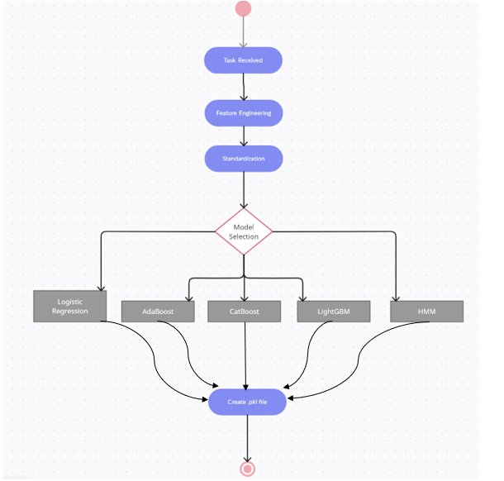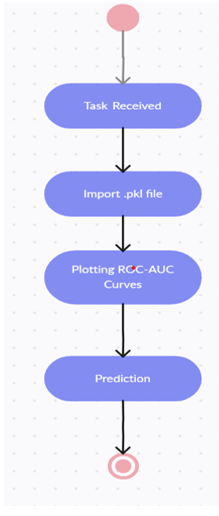

1. **Work Done :**

EDA AND FEATURE ENGINEERING:

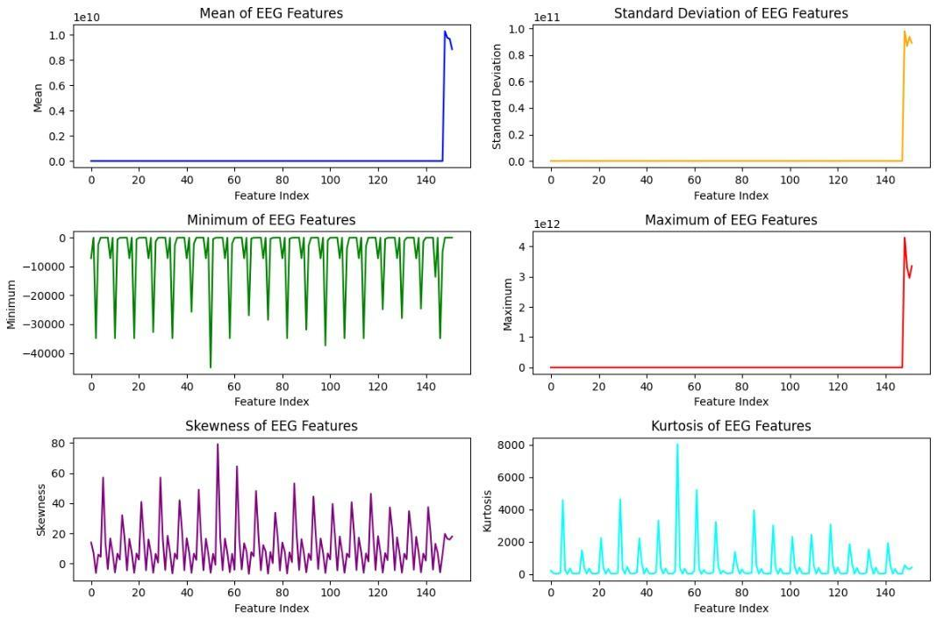

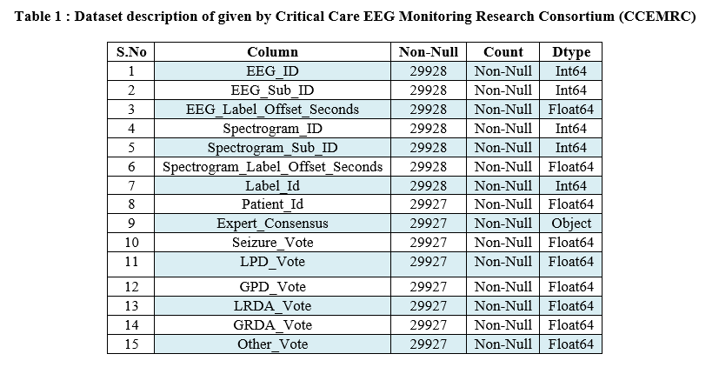

FRONTEND:

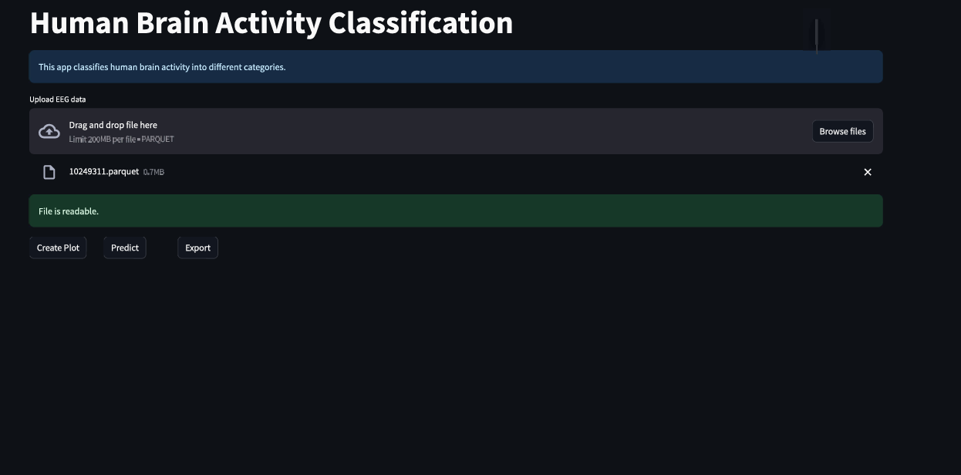

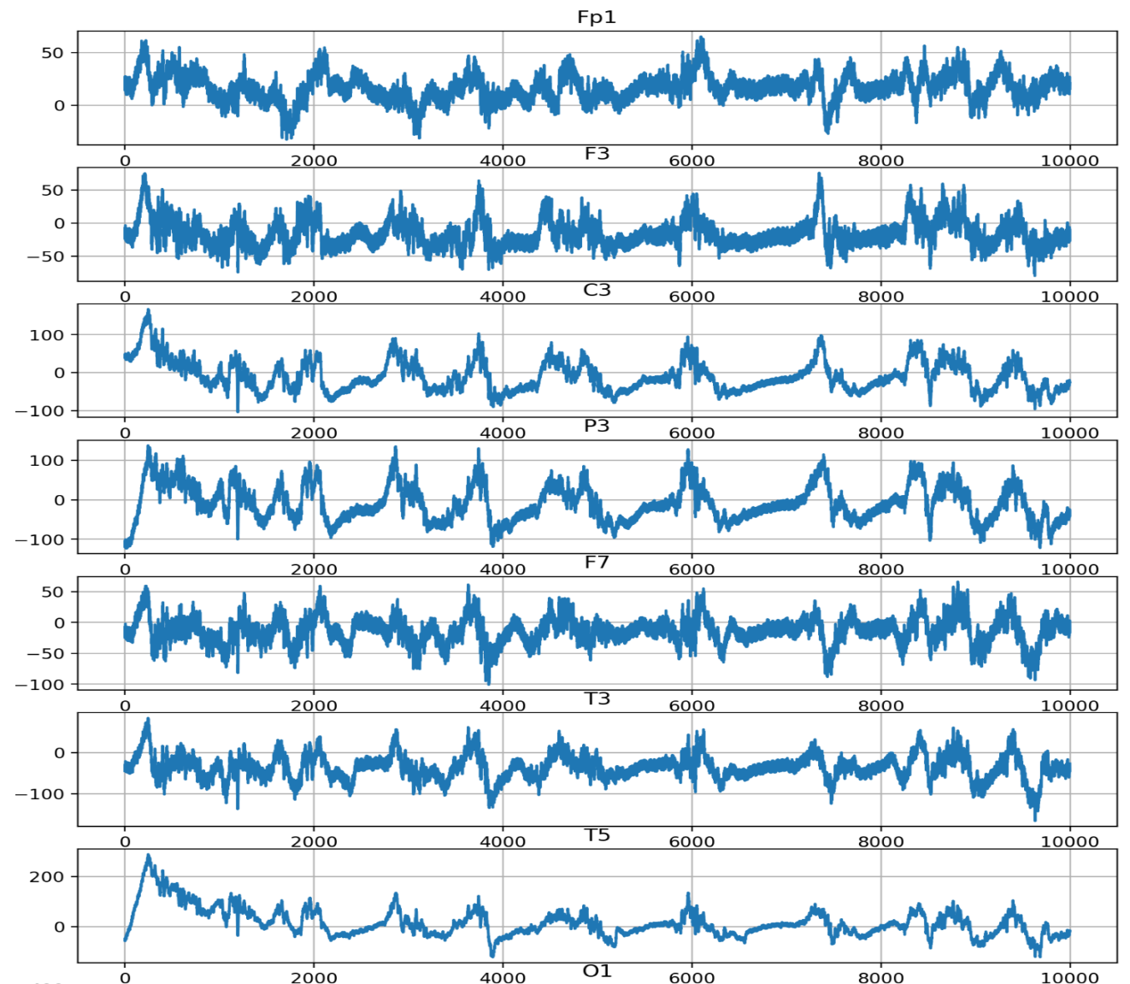

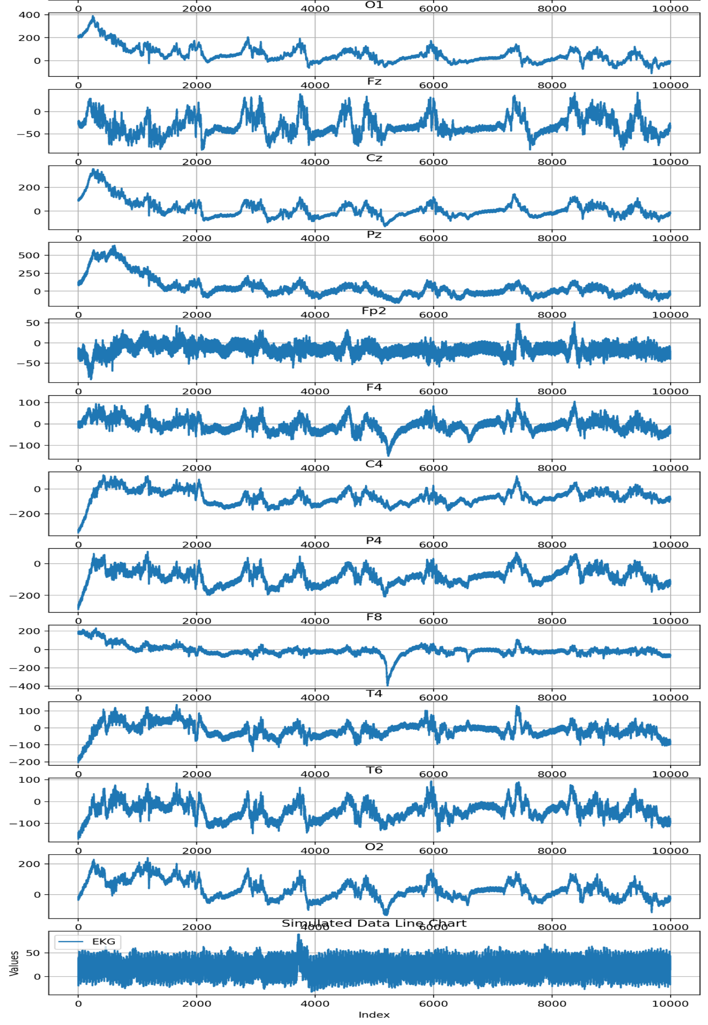

1. **References**

1. Jing, J., Ge, W., Hong, S., Fernandes, M. B., Lin, Z., Yang, C., & Westover, M. B. (2023). Development of expert-level classification of seizures and rhythmic and periodic patterns during EEG interpretation. Neurology, 100(17), e1750-e1762.

2. Miltiadous, A., Tzimourta, K. D., Giannakeas, N., Tsipouras, M. G., Glavas, E., Kalafatakis, K., & Tzallas, A. T. (2022). Machine learning algorithms for epilepsy detection based on published EEG databases: A systematic review. IEEE Access, 11, 564-594.

3. Scheuer, M. L., Wilson, S. B., Antony, A., Ghearing, G., Urban, A., & Bagić, A. I. (2021). Seizure detection: interreader agreement and detection algorithm assessments using a large dataset. Journal of clinical neurophysiology, 38(5), 439-447.

4. Azizi, T. (2024). Disrupted organization of dynamic functional networks with application in epileptic seizure recognition. Neuroscience Informatics, 4(1), 100153.

5. Lopez, S., Suarez, G., Jungreis, D., Obeid, I., & Picone, J. (2015, December). Automated identification of abnormal adult EEGs. In 2015 IEEE signal processing in medicine and biology symposium (SPMB) (pp. 1-5). IEEE.

6. Roy, S., Kiral-Kornek, I., & Harrer, S. (2019). ChronoNet: A deep recurrent neural network for abnormal EEG identification. In Artificial Intelligence in Medicine: 17th Conference on Artificial Intelligence in Medicine, AIME 2019, Poznan, Poland, June 26–29, 2019, Proceedings 17 (pp. 47-56). Springer International Publishing.

7. Trejo, L. J., Kubitz, K., Rosipal, R., Kochavi, R. L., & Montgomery, L. D. (2015). EEG-based estimation and classification of mental fatigue. Psychology, 6(5), 572-589.

8. Pohlmann-Eden, B., Hoch, D. B., Cochius, J. I., & Chiappa, K. H. (1996). Periodic lateralized epileptiform discharges—a critical review. Journal of clinical neurophysiology, 13(6), 519-530.

9. Fung, F. W., Parikh, D. S., Massey, S. L., Fitzgerald, M. P., Vala, L., Donnelly, M., ... & Abend, N. S. (2021). Periodic and rhythmic patterns in critically ill children: incidence, interrater agreement, and seizures. Epilepsia, 62(12), 2955-2967.

10. Sopic, D., Aminifar, A., & Atienza, D. (2018, May). E-glass: A wearable system for real-time detection of epileptic seizures. In 2018 IEEE International Symposium on Circuits and Systems (ISCAS) (pp. 1-5). IEEE.

11. Sehgal, N., Mehra, H., Vij, S., & Virmani, D. (2023, August). An Experimental Study to Perform Bioinformatics Based on Heart Disease Case Study Using Supervised Machine Learning. In International Conference on Artificial Intelligence on Textile and Apparel (pp. 241-253). Singapore: Springer Nature Singapore.